Assignment # 2  
JAVASCRIPT

**VARIABLES FOR STRINGS**

1. Declare a variable called ***username*.**
2. Declare a variable called ***myName*** & assign to it a string that represents your Full Name.
3. Write script to
4. Declare a JS variable, titled ***message.***
5. Assign “***Hello World***” to variable ***message***
6. Display the message in alert box.
7. 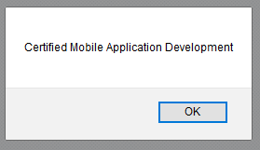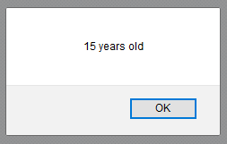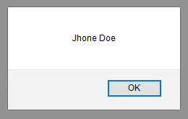Write a script to save student’s bio data in JS variables and show the data in alert boxes.
8. 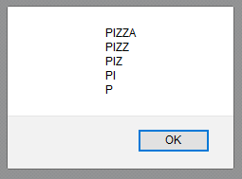Write a script to display the following alert using one JS variable:
9. Declare a variable called ***email*** and assign to it a string that represents your Email Address(e.g. [example@example.com](mailto:example@example.com)). Show the blow mentioned message in an alert box.(Hint: use string concatenation)

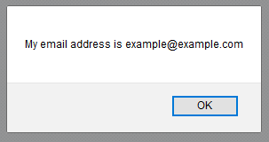

1. 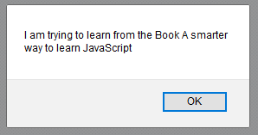Declare a variable called book & give it the value “A  
   smarter way to learn JavaScript”. Display the following  
   message in an alert box:
2. 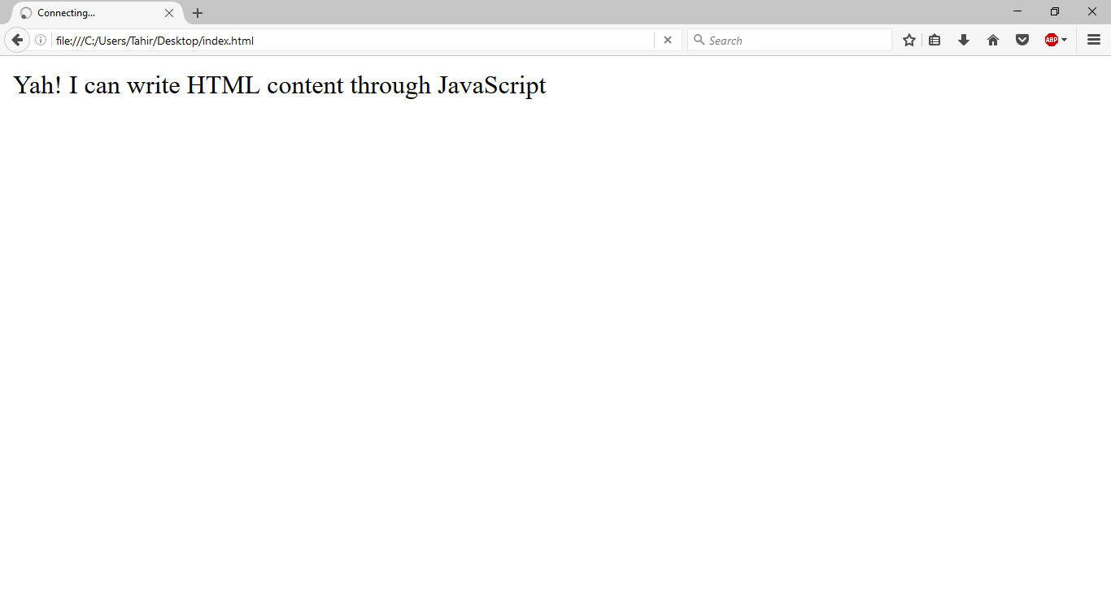Write a script to display this in browser through JS
3. Store following string in a variable and show in alert and browser through JS

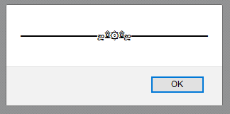“▬▬▬▬▬▬▬▬▬ஜ۩۞۩ஜ▬▬▬▬▬▬▬▬▬”

**-- END --**